

# Acropolis Institute of Technology & Research, Indore

### Department of IT (Information Technology)

A

Synopsis Report On

Minor Project

**Credit Card Fraud Detection**

|  |  |
| --- | --- |
| **Guided By** | **Submitted By** |
| Prof. Manish Vyas | Khushi Agrawal (0827IT221076) |
|  | Amay Saxena (0827IT221014) |
|  | Akshat Soni (0827IT221011) |
|  | Ameer Saif Khan (0827IT221015) |

Department of IT (Information Technology) Acropolis Institute of Technology & Research, Indore Session Sep-Jan (2024-25)



# Acropolis Institute of Technology & Research, Indore

### Department of IT (Information Technology)

A

Synopsis Report On

Minor Project

**Credit Card Fraud Detection**

# INTRODUCTION:

## Overview:

* + - **What Is Credit Card Fraud Detection?**

Credit card fraud detection is a set of methods and techniques designed to block fraudulent purchases, both online and in-store. This is done by ensuring that you are dealing with the right cardholder and that the purchase is legitimate. Overall, credit card fraud detection is a critical area of research in the financial industry, with significant potential for improving fraud detection rates and reducing financial losses.

## Purpose of the project/Innovativeness and usefulness:

The purpose of this project is to detect the fraudulent transactions made by credit cards. The primary purposes of this project are as follows:

* **Prevent Fraud:** By identifying fraudulent transactions early on, organisations can protect their clientele and minimise financial losses.
* **Reduce costs:** Reduce manual intervention and chargebacks to save time and resources.
* **Ensure Scalability:** Offer a system that complies with financial standards and can expand across sectors.

# LITERATURE SURVEY:

## Existing Problem:

The existing systems designed to address sign language recognition have several limitations:

* + - **Limitations of Rule-Based Systems:** These systems are only effective based on predefined rules and may fail to detect new or evolving types of fraud.
    - **Inability to Adapt:** Rule-based systems struggle to adapt to new fraud patterns as they rely on static, predefined rules.
    - **Challenges with Traditional Methods:** While machine learning algorithms and statistical techniques offer improvements, they still face challenges in fully capturing complex and dynamic fraud patterns.

## Proposed Solution:

* + - **Suggested Solution**
      * The model used must be simple and fast enough to detect the anomaly and classify it as a fraudulent transaction as quickly as possible.
      * Imbalance can be dealt with by properly using some methods which we will talk about in the next paragraph.
      * For protecting the privacy of the user the dimensionality of the data can be reduced.
      * A more trustworthy source must be taken which double-check the data, at least for training the model.

# THEORETICAL ANALYSIS:

## Block Diagram:

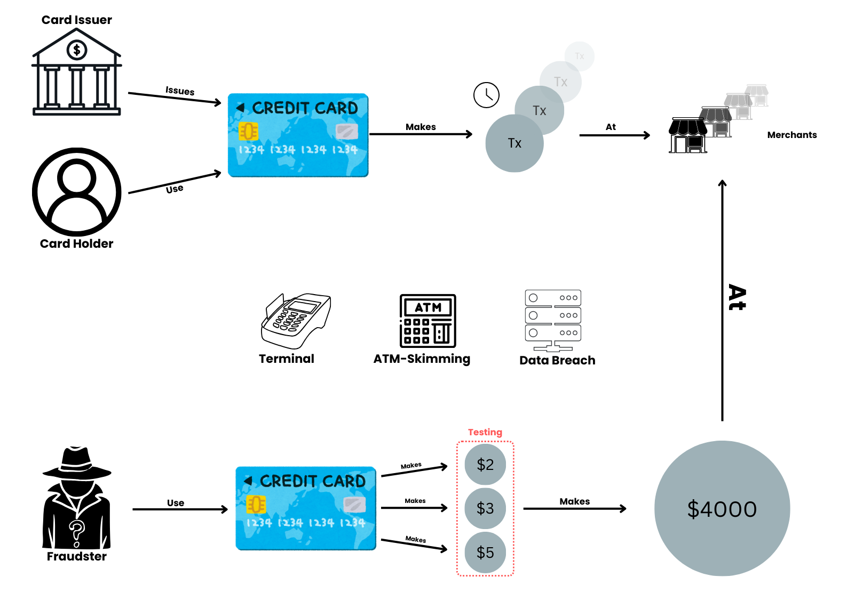

* **Acquiring Card Information**: Fraudsters obtain credit card details through skimming or data breaches.
* **Initial Testing**: They start with small transactions, around $2-$3, at common merchants like Starbucks.
* **Gradual Increase**: Transaction amounts are increased to test the card's usability.
* **Final Large Purchase**: Once confirmed, they make a big purchase using the card.
* **Switching to New Cards**: After validation, they move on to the next stolen card.
* **Role of Graph Databases**: These databases help detect such testing patterns, preventing large fraudulent transactions.
  1. **Required Resources:**

### Hardware Requirements:

1. **Computer/Server:** To develop and train machine learning models, you'll need a computer with sufficient processing power (CPU/GPU) and memory (RAM), especially if you're working with large datasets.
2. **Storage Devices:** A high-capacity SSD or external storage for large datasets.

### Software Requirements:

1. Python (Scikit-learn, TensorFlow, PyTorch).
2. R: For statistical analysis.
3. Libraries: Scikit-learn, Pandas, NumPy (data manipulation and machine learning).
4. TensorFlow/PyTorch: for advanced models.
5. Data Storage: MySQL/PostgreSQL (relational databases).
6. MongoDB (non-relational databases).

# METHODOLOGY TO BE ADOPTED/ PLANNING OF WORK:

The project methodology and work plan involve the following key phases:

### Data Collection:

Gather data using past transaction records from financial institutions. Public datasets such as those from Kaggle can complement real data.

### Data Preprocessing:

Clean and preprocess the collected data. This includes data augmentation, normalization, and labeling.

### Model Development:

Create a credit card fraud detection model using deep learning techniques like convolutional neural networks (CNNs) or recurrent neural networks (RNNs).

### Real-Time Recognition:

Implement the model to provide real-time credit card fraud recognition. This phase involves integrating the trained model into a functional system.

### Testing and Evaluation:

Rigorously test the system's accuracy, performance, and reliability. Identify and address any issues or discrepancies in the recognition process.

### User Interface:

Develop an intuitive and user-friendly interface for the system. Ensure that it is accessible and easy to use for the end users.

### Documentation:

Create comprehensive project documentation, including user manuals, installation guides, and technical documentation for system maintenance.

# APPLICATIONS:

Credit card fraud detection is used in various applications:

* **Online Retailers:** To prevent unauthorized transactions and protect against fraud in e-commerce.
* **Banking and Financial Institutions:** For securing online and in-store transactions and monitoring account activities.
* **Mobile Payments:** To ensure secure transactions through apps and mobile wallets.
* **Insurance Companies:** To identify fraudulent claims and ensure legitimate transactions.

## IMPACT OF THE WORK ON REAL LIFE / END USER:

* **Financial Protection**: Effective fraud detection systems can help prevent unauthorized transactions, protecting users from financial losses.
* **Increased Trust**: When users know that their financial institutions have robust fraud detection measures in place, they are more likely to trust and use their services.
* **Impact on Credit Scores:** Rapid detection can limit the duration and impact of fraud on a user's credit score, helping them maintain a healthier financial profile.
* **User Experience:** Effective fraud detection can balance security and convenience, ensuring that legitimate transactions are not unnecessarily flagged, enhancing the overall user experience.

## EXPECTED OUTCOMES/BENEFITS:

The expected outcomes and benefits of credit card fraud detection for end users include:

### Financial Security

* **Prevention of Unauthorized Transactions**: Users are protected from fraudulent transactions, reducing or eliminating potential financial losses.

### Quick Issue Resolution

* **Faster Dispute Settlements**: Fraud detection systems typically notify users of suspicious activity in real-time, allowing for rapid resolution of disputes.

### Better Transaction Experience

* **Seamless Usage with Security**: With effective fraud detection in place, legitimate transactions are processed smoothly without unnecessary declines, while fraud attempts are flagged instantly.

### Enhanced Fraud Awareness

* **Increased Vigilance Among Users**: Regular alerts and notifications raise awareness about potential threats, encouraging users to adopt better security practices like monitoring account activity.

# REFERENCES:

* 1. **Bence Jendruszak (2024).** Credit Card Fraud Detection: What is It, How It Works and Its Importance**:** [https://seon.io/resources/credit-card-fraud-](https://seon.io/resources/credit-card-fraud-detection/) [detection/](https://seon.io/resources/credit-card-fraud-detection/)
  2. **Ravindra Saini (2023).** A Survey on Detection of Fraudulent Credit Card Transactions Using Machine Learning Algorithms**:** <https://ieeexplore.ieee.org/document/10076122>
  3. **Malam Alamri (2022).** Survey of Credit Card Anomaly and Fraud Detection Using Sampling Techniques:

<https://safetyculture.com/topics/data-collection/>